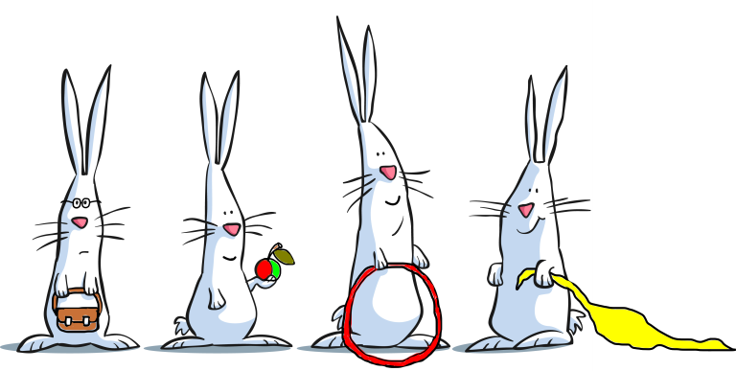

Bunnies Pre-school
Child Registration Form

All details that are provided are kept strictly confidential
Child’s full legal name:
Name child known by:

Child’s date of birth: Gender: M/F

Full name, address and occupation of parent(s)/carer(s) with whom the above child lives-

1.  Occupation | 2.  Occupation
Does this individual have parental responsibility? YES / NO | Does this individual have parental responsibility? YES / NO
Does this individual have legal access to the above named child? YES / NO | Does this individual have legal access to the above named child? YES / NO
Email address(s): (where correspondence will go to)

Telephone No: (home)

Mobile No(s):

Work No(s):

Previous address if moved in last 3 years: | Previous address if moved in last 3 years:
Full Name, address and occupation of parent(s) with whom the child does not live (if applicable):
1  Occupation | 2  Occupation
Does this parent have parental responsibility? YES/NO | Does this parent have parental responsibility? YES/NO
Does this parent have legal access to the above named child? YES/NO | Does this parent have legal access to the above named child? YES/NO
Email address(s): | Work No(s):
Telephone No: (home) | Mobile No(s):
Family Doctor:

Practice Address:

Telephone No:

Health Visitor: Tel no:

Are any other professionals working/supporting your child, (e.g. speech therapist, social worker, child psychiatrist, occupational therapists, physiotherapists): YES/NO

Emergency Contact Details
You will be asked to provide details of at least two people that in your absence could collect your child from Bunnies. You will fill these out on an emergency contact sheet before your child starts, so please consider whom this will be.

PREFERRED DAYS: (please tick)
We will try to accommodate your preference subject to vacancies. You will be contacted to confirm days.

SESSIONS: 9am-12pm and 12.20pm-2.50pm

FEES: At present- £29.10 per morning session, and £25.50 per afternoon, unless funded by Early Years Free Entitlement. To stay on into the afternoon and be supervised eating a packed lunch we charge £4.50 per child per lunch.
Requested sessions.
Monday  AM |  | Tuesday AM |  | Wednesday AM |  | Thursday AM |  | Friday AM
 |  |  |  | Wednesday PM |  | Thursday PM

YES/NO
I would like to register my child for Forest school sessions on Wednesday afternoons (finishes at 2.30pm)
Term you would like to start this (can do 2 consecutive terms):-

Please note: If appropriate, we may need to change the sessions your child attends to meet his/her individual needs. This is not often needed and if such a situation should arise you will be consulted fully.

Preferred Start Date__________________________________

Personal Details of your Child.
Does your child have any allergies/intolerances or a medical condition of which the staff should be made aware? YES/ NO (if yes please give details)

Please give details of any special dietary needs or preferences for your child

Does your child need medication administered whilst at Bunnies (e.g. Inhaler etc.)? YES/NO (if yes please give details – attach to form if easier)

Has your child attended another setting or registered child minder before or at present? YES/NO
(if Yes please give details)

Does your child drink milk YES/NO

Does your child have any special needs? Have any additional needs been identified by other professionals ?(if yes please give details-attach a form if easier),

Has your child had all vaccinations advised by the health authorities? Yes/No
If you have opted out of any vaccinations or there is a medical reason your child can not have any of them please list vaccinations not received below, so we can be vigilant with signs and symptoms.

Is the family/child being supported by children’s services or social services?
YES/NO

Do you have an Early Help Assessment or have you had in the past? YES/NO

About the Family Environment (additional information)
How would you describe your child’s ethnicity or cultural background? (e.g. White British, Indian, Chinese)

All languages spoken at home
1.
2.
3.
If English is not the main language spoken at home, will this be your child’s first experience of being in an English-speaking environment? | YES/NO
What is the main religion in your family (if applicable? e.g. C of E, Catholic, Muslim)

Are there any festivals or special occasions celebrated in your culture that your child will be taking part in and that you would like to see acknowledged and celebrated while he/she is in our setting? | Is there any other information we may need to fully support your child in their learning at pre-school? Behaviours unique to your culture that we may not be aware of?
The Government gives extra funding to childcare providers, called the Early Years Pupil Premium (EYPP), for every child meeting certain criteria.
Your child may be eligible for the EYPP if you get any of these benefits:

- Income Support
- Income-based Jobseeker's Allowance
- Income-related Employment and Support Allowance
- Support under Part VI of the Immigration and Asylum Act 1999
- The guaranteed element of State Pension Credit
- Child Tax Credit, (provided you are not also entitled to Working Tax Credit and have an annual gross income of no more than £16,190)
- Working Tax Credit 'run-on' - the payment someone may receive for a further four weeks after they stop qualifying for Working Tax Credit

If any of the above apply or you have had FEET funding for your child previously, please confidentially speak to Emma, or highlight the criteria you meet above.

We may also be able to get the extra funding if your child:

- Has been Iooked after by the local authority for at least one day
- Has been adopted from care
- Has left care through special guardianship
- Is subject to a child arrangement order.

If you think that your child could be eligible, please again speak confidentially to Emma or highlight the criteria you meet above.

Please return completed forms to either our e-mail address: emma@bansteadbunnies.co.uk or our correspondence address: 16 Fir Tree Close, Epsom Downs, Surrey. KT173LD.

