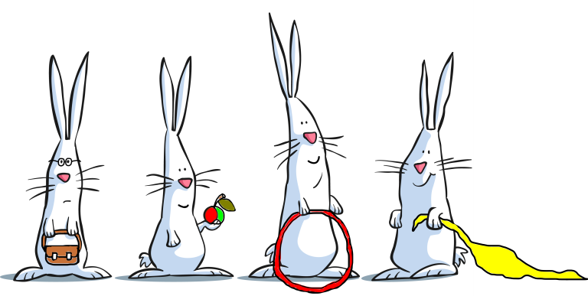

Banstead Bunnies Preschool
Child Registration Form

All details that are provided are kept strictly confidential.
Child’s full legal name:
Name child known by:

Child’s date of birth: Gender: M/F

Full name, address, and occupation of parent(s)/carer(s) with whom the above child lives-

Occupation | 2.  Occupation
  1.
Does this individual have parental responsibility? YES / NO | Does this individual have parental responsibility? YES / NO
Does this individual have legal access to the above-named child? YES / NO | Does this individual have legal access to the above-named child? YES / NO
Email address(s): (where correspondence will go to)

Telephone No: (home)

Mobile No(s):

Work No(s):

Previous address if moved in last 3 years: | Previous address if moved in last 3 years:
Full Name, address and occupation of parent(s) with whom the child does not live (if applicable):
1  Occupation | 2  Occupation
Does this parent have parental responsibility? YES/NO | Does this parent have parental responsibility? YES/NO
Does this parent have legal access to the above-named child? YES/NO | Does this parent have legal access to the above-named child? YES/NO
Email address(s): | Work No(s):
Telephone No: (home) | Mobile No(s):
Family Doctor:

Practice Address:

Telephone No:

Health Visitor: Tel no:

Are any other professionals working/supporting your child, (e.g. speech therapist, social worker, child psychiatrist, occupational therapists, physiotherapists): YES/NO

Emergency Contact Details
You will be asked to provide details of at least two people that in your absence could collect your child from Bunnies. You will fill these out on an emergency contact sheet before your child starts, so please consider whom this will be.

PREFERRED DAYS: (please tick)
We will try to accommodate your preference subject to vacancies. You will be contacted to confirm days.
SESSIONS: 9am-12pm and 12pm-2.50pm
FEES: At present- £29.10 per 3-hour session, unless funded by Funded Early Education (FEE), Working Parents Entitlement or Funded Early Education for two-year-olds (FEET).
Children are required to bring a healthy packed lunch if they are staying for a morning and afternoon session.
Please note additional costs are requested for extracurricular activities.
Breakfast Club is available on an ad hoc basis for £6.50 per session. This will run Monday to Friday 8.35am – 9am. Please provide us with 24 hours’ notice should you require a session.

Requested sessions.
Breakfast club
Monday |  | Tuesday |  | Wednesday |  | Thursday |  | Friday

Sessions
Monday  AM |  | Tuesday  AM |  | Wednesday AM |  | Thursday AM |  | Friday AM
 |  | Tuesday  PM |  | Wednesday PM |  | Thursday PM

Please note: If appropriate, we may need to change the sessions your child attends to meet his/her individual needs. This is not often needed and if such a situation should arise you will be consulted fully.
Preferred Start Date__________________________________

Personal Details of your Child.
Does your child have any allergies/intolerances or a medical condition of which the staff should be made aware? YES/ NO (if yes please give details)

Please give details of any special dietary needs or preferences for your child

Does your child need medication administered whilst at Bunnies (e.g. Inhaler etc.)? YES/NO (if yes please give details – attach to form if easier)

Has your child attended another setting or registered child minder before or at present? YES/NO
(if yes please give details)

Does your child drink milk YES/NO

Does your child have any special needs? Have any additional needs been identified by other professionals? (if yes please give details-attach a form if easier),

Has your child had all vaccinations advised by the health authorities? Yes/No
If you have opted out of any vaccinations or there is a medical reason your child can not have any of them, please list vaccinations not received below, so we can be vigilant with signs and symptoms.

Is the family/child being supported by children’s services or social services?
YES/NO

Do you have an Early Help Assessment, or have you had in the past? YES/NO

About the Family Environment (additional information)
How would you describe your child’s ethnicity or cultural background? (e.g. White British, Indian, Chinese)

All languages spoken at home
1.
2.
3.
If English is not the main language spoken at home, will this be your child’s first experience of being in an English-speaking environment? | YES/NO
What is the main religion in your family (if applicable? e.g. C of E, Catholic, Muslim)

Are there any festivals or special occasions celebrated in your culture that your child will be taking part in and that you would like to see acknowledged and celebrated while he/she is in our setting? | Is there any other information we may need to fully support your child in their learning at pre-school? Behaviours unique to your culture that we may not be aware of?
Universal Entitlement for three- and four-year-olds. In England, all three and four-year-olds are
entitled to up to 15 hours of funded early education and childcare a week for up to 38 weeks a year.
This is a universal offer and is available to all children regardless of their family circumstances.

The Government provides additional funding to childcare providers, called the Early Years Pupil Premium (EYPP), for every child meeting the criteria. This funding is used to further support your child within the setting. This may be through specialist training for staff or new experiences for your child.

If your family receives one of the following benefits, then your child may be eligible to claim Funded Early Education for Two-year-olds (FEET). Once your child has been agreed for FEET they will continue to be funded even if your family does not meet the criteria later.

- Income Support
- Income-based Jobseeker's Allowance (JSA)
- Income-related Employment and Support Allowance (ESA)
- Universal Credit, and your household income is £15,400 a year or less after tax, not including benefit payments
- The Guaranteed element of Pension Credit.

Claiming FEET does not affect your benefits.

Funded Early Education for two-year-olds (FEET) offers eligible families up to 15 hours of funded early education and childcare a week for 38 weeks a year. You can find out if your child can access two-year-old funding by checking the eligibility criteria below.

Working Parent’s Entitlement is available for working families who meet the eligibility criteria can claim up to 15 or 30 hours of childcare per week.
- Eligible working parents of children aged three to four years can access 30 hours funded early education and childcare (for 38 weeks of the year) from the term following their child turning three years old.

Applications must be made through the HMRC's Best Start in Life website. If you're unable to apply online or have any problems with the application process, please contact HMRC's Childcare Service Customer Interaction Centre on 0300 123 4097 for support.

Please remember you need to renew your code every three months to continue claiming the funding.

If you think that your child could be eligible, please again speak confidentially to Jo or highlight the criteria you meet above.

Please return completed forms to either our email address: jo@bansteadbunnies.co.uk or our correspondence address: Flat 2 Outwood Court, 220 Pampisford Road, South Croydon, Surrey, CR2 6DB.

